Supporting Information:

Impact of Phosphate Addition on PFAS Treatment Performance for Drinking Water

Levi M. Hauperta, Adam Reddingb, J. Margaret Grayc, John Civardic, Boris Datsovd, Toby T. Sanana, Marc A. Millsa, Thomas F. Spetha, Jonathan B. Burkhardta*

a U.S. Environmental Protection Agency, Office of Research and Development, Center for Environmental Solutions and Emergency Response, 26 West Martin Luther King Drive, Cincinnati, OH 45268

b Calgon Carbon, 3000 GSK Drive, Moon Township, PA 15108

c Mott MacDonald, 111 Wood Avenue South, Iselin, NJ 08830

d ORAU Student Services Contractor, Oak Ridge Associated Universities, 26 West Martin Luther King Drive, Cincinnati, 45268

* Corresponding author: [burkhardt.jonathan@epa.gov](mailto:burkhardt.jonathan@epa.gov), ORCID: 0000-0002-2935-4422

# S1 TOC, Alkalinity, and Major Anion Feed Concentrations

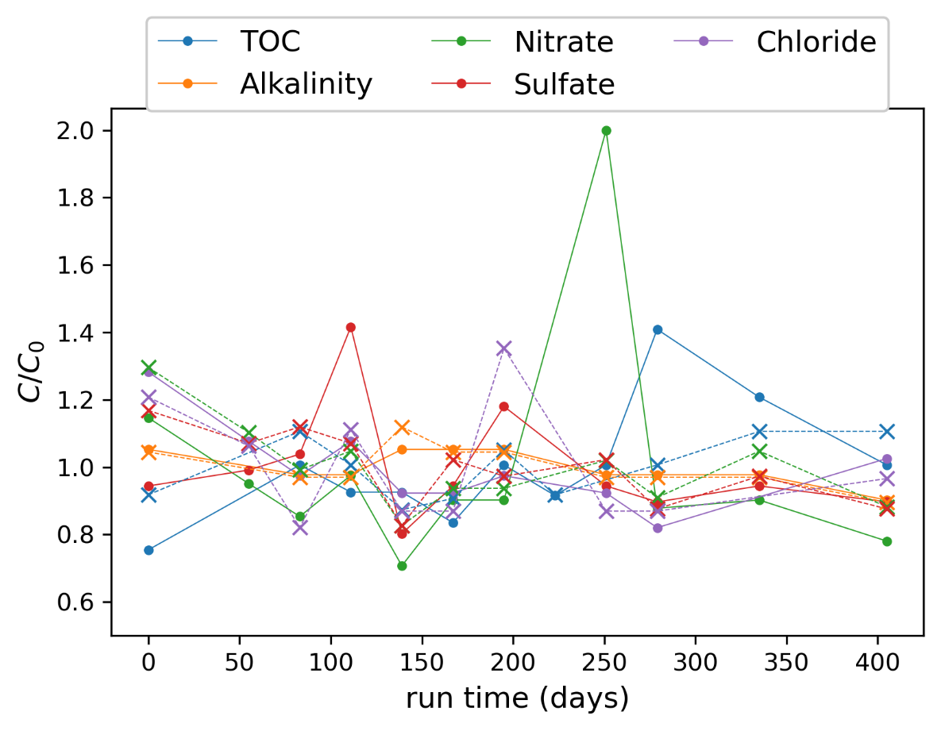

Figure S1 Normalized influent concentrations for TOC, alkalinity, and major anion in process feeds of the pre-AS (“—o”) and post-AS (“--x”) IX treatment trains. Concentrations are normalized by average influent concentrations ().

# S2 Estimating Fouling Impact from GAC Pilot Data

The Freundlich isotherm capacity () was determined by calculating the average molar reduction that would occur relative to the water and species type for a given compound during its pre-breakthrough period. The effective adsorption capacity, , was calculated by integrating between the influent and effluent curves prior to the complete breakthrough (i.e., when effluent C equals influent C). Assuming a simple mass loading assumption for determining mass balance yields Eq. SI-1. Where is equal to the average influent concentration () at expected breakthrough time () divided by carbon mass ().

|  |  |
| --- | --- |
|  | SI - 1 |
|  | SI - 2 |
|  | SI - 3 |

The combined fouling molar reduction formula is shown in Eq. SI-2. Eq. SI-3 can be derived by integrating Eq. SI-2 during the pre-breakthrough period (t, 0 to ), where Karlsruhe fouling parameters are A1 = 0.650, A2 = -6.71E-7 min­-1, and A­3 = -1E-4 min-1. Previously derived and parameters are shown in Table SI-1 which were developed in Burkhardt et al. 2022. To get the average impact the results of Eq. SI-3 must be divided by and the inverse of these values will give you the factors for multiplying estimated Freundlich s by to capture effective unfouled capacities. These effective unfouled capacities are supplied to the model and are presented in the main body of this work.

Table SI- 1: PFAS specific fouling parameters (taken from Burkhardt et al. 2022)

|  |  |  |  |
| --- | --- | --- | --- |
| **Compound (acronym)** | **CAS#** | **QSPR Fouling Parameters** | |
| **a** | **b** |
| Perfluorobutanoic acid (PFBA) | 375-22-4 | 0.82 | 0.12 |
| Perfluoropentanoic acid (PFPeA) | 2706-90-3 | 0.67 | 0.19 |
| Perfluorohexanoic acid (PFHxA) | 307-24-4 | 0.55 | 0.28 |
| Perfluoroheptanoic acid (PFHpA) | 375-85-9 | 0.44 | 0.36 |
| Perfluorooctanoic acid (PFOA) | 335-67-1 | 0.34 | 0.44 |
| Perfluorononanoic acid(PFNA) | 375-95-1 | 0.24 | 0.53 |
| Perfluorodecanoic acid (PFDA) | 335-76-2 | 0.17 | 0.61 |
| Perfluorobutanesulfonic acid (PFBS) | 375-73-5 | 0.68 | 0.24 |
| Perfluorohexanesulfonic acid (PFHxS) | 355-46-4 | 0.44 | 0.48 |
| Perfluorooctanesulfonic acid (PFOS) | 1763-23-1 | 0.25 | 0.66 |
| Perfluoro-2-methoxyacetic acid (PFMOAA) | 674-13-5 | 0.88 | 0.055 |
| Perfluoro(3,5-dioxahexanoic) acid (PFO2HxA) | 39492-88-1 | 0.63 | 0.17 |
| Perfluoro(3,5,7-trioxaoctanoic) acid (PFO3OA) | 39492-89-2 | 0.43 | 0.27 |
| Perfluoro-2-proxypropanoic acid (PFPrOPrA/GenX) | 13252-13-6 | 0.50 | 0.37 |
| Perfluoro(3,5,7,9-tetraoxadecanoic) acid (PFO4DA) | 39492-90-5 | 0.25 | 0.37 |
| Ethanesulfonic acid, 2-1[1-[difluoro(1,2,2,2-tetrafluoroethoxy)methyl]-1,2,2,2-tetrafluoroethoxy]-1,1,2,2-tetrafluoro- (Nafion BP2) | 749836-20-2 | 0.29 | 0.63 |

Table SI-2: Freundlich K values for Calgon F400 estimated from pilot data using linearized isotherm (1/n = 1)

|  |  |
| --- | --- |
| **PFAS** | **K (μg/g)(L/μg)1/n** |
| PFBA | 6.23 |
| PFPeA | 49.33 |
| PFHxA | 50.20 |
| PFHpA | 57.17 |
| PFOA | 66.67 |
| PFNA | 47.04 |
| PFBS | 65.02 |
| PFPeS | 71.85 |
| PFHxS | 70.43 |
| PFOS | 152.71 |

# S3 Comparison of Logistic Models with HSDMIX

A commonly used empirical logistic form for breakthrough curves in fixed-bed adsorbers is given by Eq. SI-4. In this equation and are empirical fitting parameters and represents the average influent concentration.

|  |  |  |
| --- | --- | --- |
|  |  | (SI - 4) |

It is important to recognize some of the limitations of using this equation for modeling fixed-bed adsorption. It can only closely match breakthrough curves that are neatly sigmoidal and symmetric. Thus, breakthrough curves that are asymmetrical because of mass transfer limitations (important in short beds) or chromatographic effects (i.e., “roll off”, or C/C­0 > 1) will not be well described. However, even for systems with symmetric curve shapes, these models may have limited usefulness for making predictions for IX processes. There are many parameterizations of SI-4 in the literature. To analyze them all would be a considerable undertaking, so only the commonly used Thomas model, with and are defined as shown in Eq. SI-5, will be discussed in detail in this section.

|  |  |  |
| --- | --- | --- |
|  |  | (SI - 5) |

Here, represents the resin loading in equilibrium with , represents the flow rate in the system, represents the sorbent mass, and represents a rate term. The addition of several system characteristics to the parameterization may give the impression that SI-5 would be more predictive than something like Eq. 10 in the main text. However, this is not the case for modeling IX performance under conditions like those in the pilot system studied here.

Before comparing the Thomas model to HSDMIX, it is useful to modify SI-5 so that is in a volume basis (that is, converted to concentration within the resin beads). It is also potentially convenient to recast the system specification in terms of linear flow velocity and bed depth to facilitate direct comparison with HSDMIX using specifications described in the main text. Doing so results in Eq. SI-6 where is the bed porosity, is the bed depth, and is the superficial flow velocity.

|  |  |  |
| --- | --- | --- |
|  |  | (SI - 6) |

Substituting Eq. SI-6 into Eq. SI-4 results in Eq. SI-7.

|  |  |  |
| --- | --- | --- |
|  |  | (SI - 7) |

The system parameters for the Pre-AS ion exchange system were used as a baseline scenario to compare the HSDMIX and Thomas models. However, the bed depth was extended to 165 cm to ensure a well-developed mass transfer zone and good correspondence between the curve shapes predicted by the two models. Only PFHxA was examined in this analysis. An average concentration of 13.6 ng/L (4.4x10-8 meq/L) was fed to both simulations. The effective separation factor between chloride and PFHxA was set to 1050. The Thomas model was then fit to the HSDMIX prediction by optimizing and using nonlinear least squares optimization. The resulting Thomas model curve indeed showed close correspondence with the HSDMIX prediction in this baseline case (Fig. S2). The fitted value for in the Thomas model was within 0.7% of the value predicted by HSDMIX, suggesting that estimating this Thomas model parameter using Eq. 5 in the main text may be appropriate in this context. The best fit value for was 10.7 L/(meq·s) and was carried forward to other scenarios to compare the behaviors of the two models.

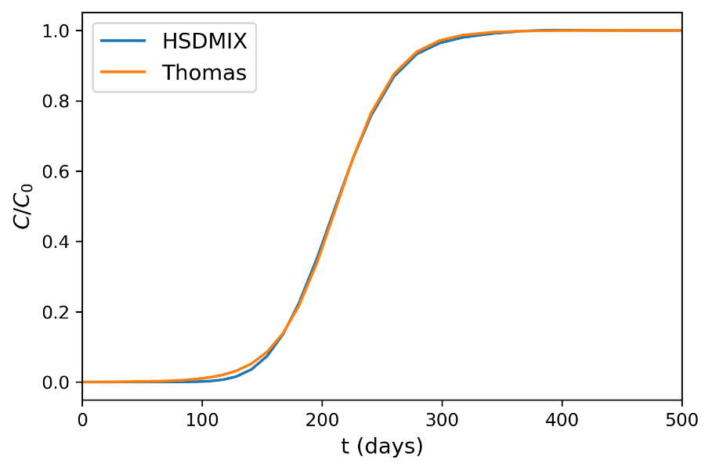

Figure S2: Regression of Thomas model to HSDMIX predicted breakthrough curve.

One application of modeling fixed-bed performance is predicting scale-up from pilot to full-scale systems. To examine this, HSDMIX and Thomas model predictions were compared with bed depth further extended to 330 cm (2x) or shortened to 41 cm (1/4 x). The underlying assumption of a constant pattern mass transfer zone in the Thomas model is evident in Figure S3. This contrasts with HSDMIX which models the development of the mass transfer zone. The short bed breakthrough curve produced by the Thomas model is more dispersed than the one from HSDMIX and features significant early breakthrough. It is, however, unlikely that the constant pattern assumption holds in this case, so the Thomas model prediction is likely erroneous. This claim is supported by the findings of Ellis et al. (Ellis et al., 2022) and Croll et al. (Croll et al., 2023), which both found differing fit parameters using constant pattern models on data from sample ports pilot systems.

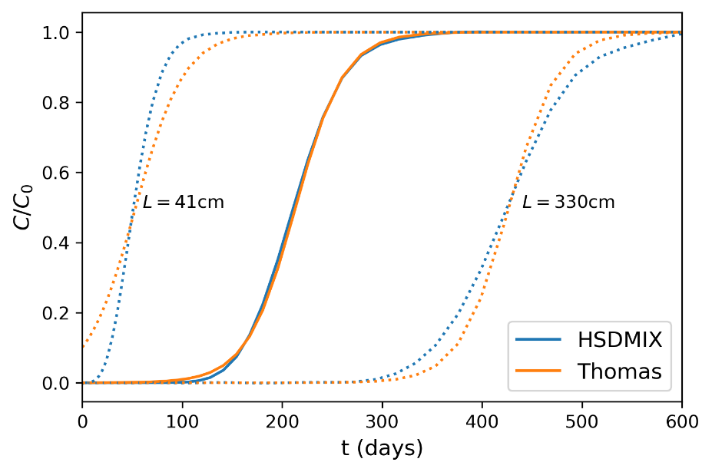

Figure S3: Effect of changing bed depth on Thomas and HSDMIX models.

The HSDMIX and the Thomas model predictions for the long bed variant do not agree either. The breakthrough curve from HSDMIX still shows some dispersion of the mass transfer zone. The Thomas model has a sharper profile for the longer bed, whereas HSDMIX predicts earlier breakthrough which could be important for bed design. The HSDMIX predictions are consistent with ion exchange theory and have been validated against some conditions, but they need more testing to determine if they are rigorously correct. For trace contaminants on a large competing background, the ion exchange isotherm becomes effectively linear (SenGupta, 2017) resulting in a mass transfer zone that is not fully self-sharpening. Thus, it does not appear that constant pattern models can predict the changes in breakthrough curve shape caused by changing system size for IX treatment of trace PFAS.

Another use case for modeling is predicting the effect of changing PFAS concentration on filter life. For this example, the concentration of PFHxA from the base case is cut in half. As predicted by ion exchange theory for trace contaminants, the concentration normalized breakthrough curve predicted by HSDMIX is unchanged by decreasing the influent concentration (Figure S4). Although cursory inspection of the Thomas model might tempt one to model the change in initial concentration by merely cutting in half, doing so neglects the dependence of on and produces an erroneous shift of the breakthrough curve toward higher BV50 (Figure S4). If is updated for the Thomas model according to Eq. 5 in the main text, the location of the breakthrough curve coincides with HSDMIX. The Thomas model, however, predicts a significant change in the shape of the breakthrough curve due to the appearance of in the exponential term of Eq. SI-7. The reason for this behavior is that the Thomas model was derived on the assumption that the kinetics of adsorption are controlled by chemical reaction rates. This assumption is not appropriate for ion exchange on full-sized resin beads because mass transport is almost certainly rate-determining in this situation (Helfferich, 1995). Thus, the more empirical logistic model presented in Eq. 10 in the main text appears to be more appropriate for modeling this scenario than the Thomas model in this circumstance because it does not include the erroneous kinetic dependence on initial concentration.

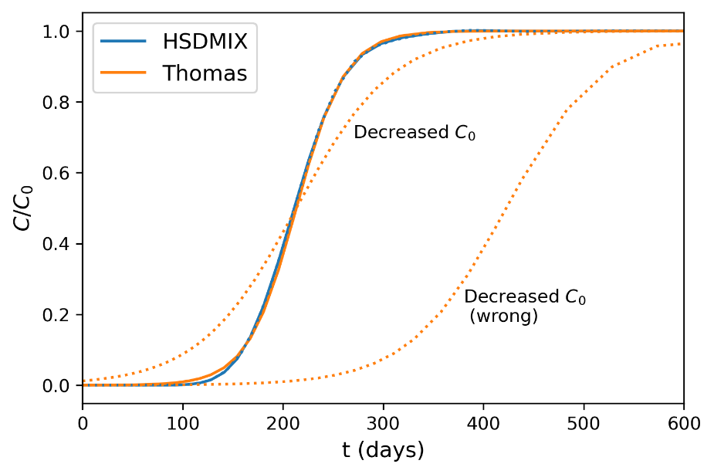

Figure S4: Effect of decreased influent PFAS concentration on Thomas and HSDMIX models. An example breakthrough curve from misapplication of the Thomas model is also shown.

Another related modeling scenario of interest is predicting the effect of changing water quality on system performance. For this example, nitrate was removed from the feed. Given the functional form of Eq. SI-7 and the assumption of a Langmuir isotherm in the Thomas model, it not necessarily obvious that it can be used to predict the effect of this change. However, the close correspondence of the Thomas and the resin loading found by HSDMIX, one approach would be to make the prediction by calculating for the Thomas model using Eq. 5 in the main text. Doing so results in a breakthrough curve with a propagation velocity very close to what HSDMIX predicts for the nitrate-free feed (Figure S5). However, the profiles of the predicted breakthrough curves differ. This disagreement is once again due to the constant pattern nature of the Thomas model not capturing the dispersion of the mass transfer zone predicted by ion exchange theory. Here again, the Thomas model is predicting a later initial breakthrough. It is worth noting that neither of these model predictions is strictly rigorous for the pilot system in this study because the complexities of natural organic matter have been glossed over.

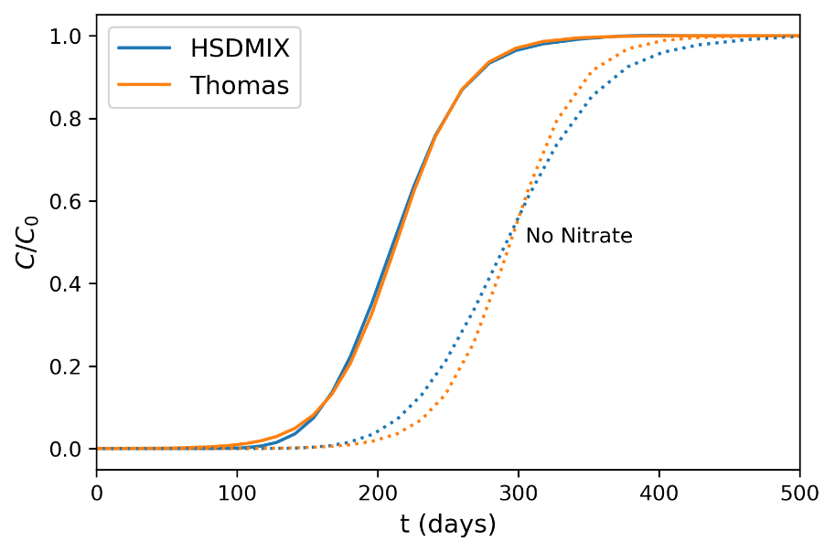

Figure S5: Effect of nitrate removal on Thomas and HSDMIX models.

In summary, the inability of constant pattern models, including the Thomas model, to predict the evolution of the mass transfer zone in IX removal of trace ions limits their ability to make useful predictions based on modeling of pilot data. The use of such models can only provide marginal additional insight over what would be obtained by a basic BV50 analysis (for instance, with Eq. 7 in the main text). However, these logistic models are still useful for data analysis tasks such as interpolation or BV50 estimation so long as it is understood that the curve shape parameters obtained in regression are purely empirical.

# S4 Additional IX Modeling Information

The numerical grid for HSDMIX modeling was constructed with nine radial (along the radii or the resin beads) and fifteen axial (along the column axis) collocation points. These values were deemed sufficient because further increasing the number of collocation points produced effectively identical PFAS breakthrough curves.

In addition to the ion exchange equilibrium and system characteristics discussed in the main text, the ion exchange model also takes two mass transport parameters as inputs. First, the film transfer coefficient () governs transport between the mobile phase and the surface of the ion exchange resins. Second, the surface diffusion coefficent () governs the transport of ions within the interior of the resin beads. Neither of these parameters are available in the literature and so must be estimated using correlations or fit from the data.

A film transfer coefficient for PFHxA (4.2 × 10-3 cm/s) was estimated at 14.4 °C using the simplified Gnielinski correlation according to the procedure found in Roberts et al. (1985). To use this correlation, estimates for PFHxA’s molar volume and aqueous diffusion coefficent were needed. A value of 182 mL/mol was used for the molar volume of PFHxA based on predictions from the ACD/Labs Percepta Platform PhysChem Module. The aqueous diffusion coefficent was estimated to be 5.2 × 10-6 cm2/s based on the correlation of Hayduk and Laudie (1974). Similar analysis estimated values of 4.8 × 10-3 cm/s for PFBA and 3.7 × 10-3 cm/s for PFOA. The difference in breakthrough curve shapes from these estimates was minor and the current implementation of the column model uses a common pair of mass transport parameters for all species, so the film transfer coefficient for PFHxA was used for all PFAS in the final analysis.

Measurements or credible estimates of the intraparticle diffusion coefficients of PFAS in ion exchange resins are absent from the literature. This parameter is, however, essential to HSDMIX and so some estimate for it is needed. It should be, in theory, possible to obtain and from the experimental data for each of the breakthrough curves in the pilot datasets. There are several practical difficulties with this approach. First, the breakthrough curves for PFOA, particularly for the pre-AS train, are incomplete, resulting in strong covariance between and during regression. On the other hand, several of the earlier eluting PFAS only have a couple of meaningful data points on their breakthrough curves, also resulting in poorly determined parameter estimates. To overcome these challenges, a hybrid optimization strategy was devised. Two-parameter optimizations were performed on PFHxA breakthrough curves, which were complete and had the largest number of data points on the rising portion of the breakthrough curve. An average value from the two PFHxA curves was then used as a fixed parameter to estimate the effective of the other PFAS. This method of estimation introduces some error. If the usual relationship between mass and diffusivity is assumed, the errors will manifest as shorter PFAS having model breakthrough curves that are too wide and longer PFAS having model breakthrough curves that are too narrow. For PFOA, this means the estimate of is likely conservatively biased. The effect of the error in on the estimates of the shorter chained PFAS is expected to be less apparent.

Estimation of and were obtained by unweighted least squares optimization. Specifically, the unweighted residual sum of squares (RSS) between the ion exchange model () and the experimental data (), calculated according to SI-8, was minimized using the differential evolution algorithm (Storn & Price, 1997) as implemented in *scipy.optimize* (Jones et al., 2014).

|  |  |  |
| --- | --- | --- |
|  |  |  |

The differential evolution algorithm was selected because a global optimization method was needed. The solutions of the ion exchange numerical model contain oscillatory components, which can result in local minima in RSS space that confound more commonly used local minimization methods. The search space for in the PFHxA optimization ranged from 1×10-12 cm2/s to 1×10-8 cm2/s. The search spaces for the PFAS  values were ± 50% of the inferred from the logistic analysis. Data below the reporting limit were treated as zeros. The average fitted for PFHxA in the two treatment trains was 1.2 × 10-9 cm2/s.

# S5 Total Organic Carbon (TOC) Breakthrough

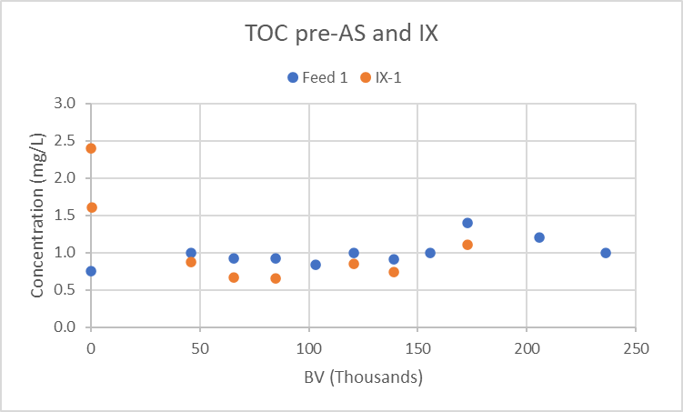

Figure S6: Pre-air stripper TOC removal by IX treatment.

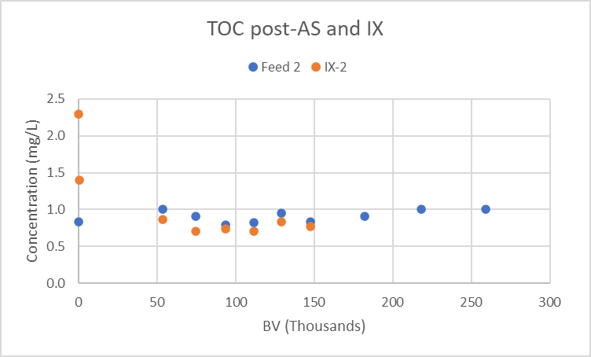

Figure S7: Post-air stripper TOC removal by IX treatment.

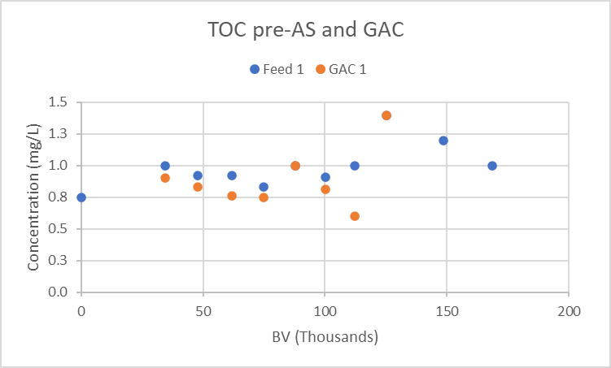

Figure S8: Pre-air stripper TOC removal by GAC treatment.

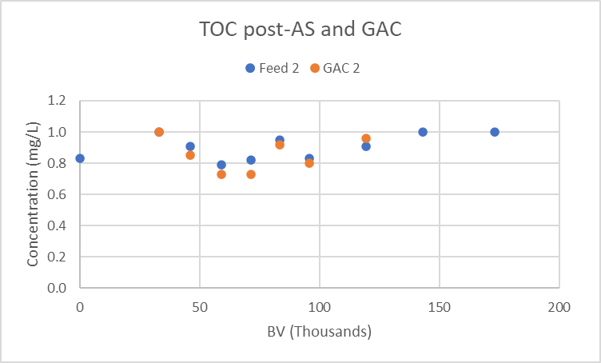

Figure S9: Post-air stripper TOC removal by GAC treatment.

# S6 Tetrachloroethene Influent and Breakthrough

Figure S10: Pre-AS removal of tetrachloroethene by GAC.

Figure S11: Pre-AS removal of tetrachloroethene by IX.

# References

Croll, H. C., Adelman, M. J., Chow, S. J., Schwab, K. J., Capelle, R., Oppenheimer, J., & Jacangelo, J. G. (2023). Fundamental Kinetic Constants for Breakthrough of Per-and Polyfluoroalkyl Substances at Varying Empty Bed Contact Times: Theoretical Analysis and Pilot Scale Demonstration. *Chemical Engineering Journal*, 142587.

Ellis, A. C., Liu, C. J., Fang, Y., Boyer, T. H., Schaefer, C. E., Higgins, C. P., & Strathmann, T. J. (2022). Pilot study comparison of regenerable and emerging single-use anion exchange resins for treatment of groundwater contaminated by per-and polyfluoroalkyl substances (PFASs). *Water Research*, *223*, 119019.

Hayduk, W., & Laudie, H. (1974). Prediction of diffusion coefficients for nonelectrolytes in dilute aqueous solutions. *AIChE Journal*, *20*(3), 611-615.

Helfferich, F. G. (1995). *Ion exchange*. Courier Corporation.

Jones, E., Oliphant, T., & Peterson, P. (2014). SciPy: Open source scientific tools for Python, 2014. *URL:* [*http://www.scipy.org*](http://www.scipy.org).

Roberts, P. V., Cornel, P., & Summers, R. S. (1985). External mass-transfer rate in fixed-bed adsorption. *Journal of Environmental Engineering*, *111*(6), 891-905.

SenGupta, A. K. (2017). *Ion Exchange in Environmental Processes: Fundamentals, Applications and Sustainable Technology*. John Wiley & Sons.

Storn, R., & Price, K. (1997). Differential evolution-a simple and efficient heuristic for global optimization over continuous spaces. *Journal of global optimization*, *11*(4), 341.